LAB EXPERIMENT
SET 13: GEOGRAPHIC DATA ANALYSIS

Department | AIDS
Course Code / Course Name | DSA0602 / Data Handling and Visualization
Experiment | Data Visualization using R and Tableau
Name | D.HEMASREE
Register Number | 192524114
Date | 8 October 2026
Day | Thursday

Aim
To analyze geographic data of cities using a map chart, a scatter plot and a data table in R, and to build an interactive dashboard using Tableau. Dataset: Geographic Data

City | Population | Avg. Temperature | Elevation
City A | 500000 | 75 | 1000
City B | 700000 | 68 | 800
City C | 600000 | 80 | 1200

PROGRAM 1: Map Chart of City Distribution
Create a map chart to visualize the distribution of cities on a geographic map. Label the map elements.
The dataset has no coordinates, so sample latitude and longitude values are assigned to each city to place it on the map.
library(ggplot2) library(maps)

geo <- data.frame(
City = c("City A", "City B", "City C"), Population = c(500000, 700000, 600000),
Avg_Temperature = c(75, 68, 80),
Elevation = c(1000, 800, 1200),
Latitude = c(35.0, 41.5, 30.0),
Longitude = c(-97.0, -88.0, -95.0)
)
usa <- map_data("usa") ggplot() +
geom_polygon(data = usa, aes(x = long, y = lat, group = group), fill = "grey90", color = "grey50") +
geom_point(data = geo,
aes(x = Longitude, y = Latitude,
size = Population, color = Avg_Temperature)) + geom_text(data = geo, aes(x = Longitude, y = Latitude, label = City),
vjust = -1.8) +

scale_color_gradient(low = "steelblue", high = "red") + coord_fixed(1.3) +
labs(title = "Distribution of Cities", x = "Longitude",
y = "Latitude", size = "Population",
color = "Avg Temperature (F)")

OUTPUT:
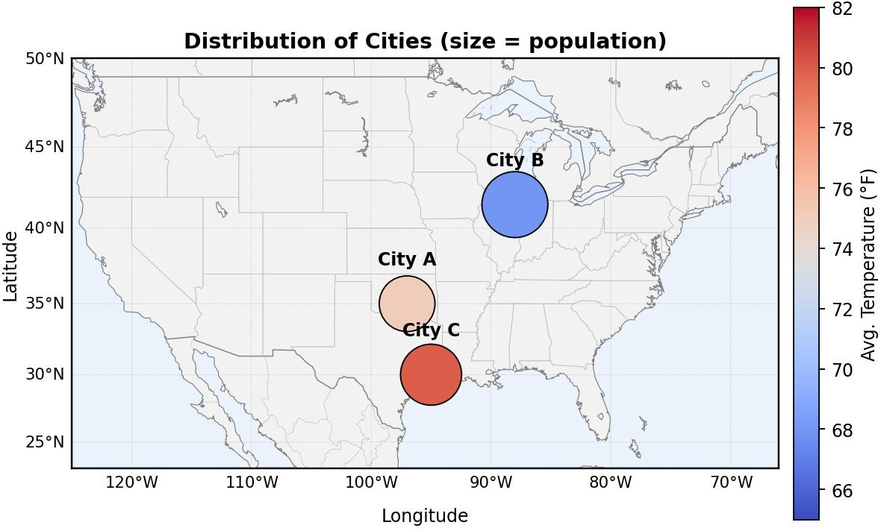

Output 1: Distribution of Cities (Map Chart)
Observation: The map places the three cities at their coordinates, with the bubble size showing population and the colour showing average temperature. City B in the north is the largest city (700,000) and the coolest (68°F). City C in the south is the warmest (80°F) with 600,000 people, and City A lies between them with the smallest population (500,000).

PROGRAM 2: Scatter Plot of Temperature vs Population
Generate a scatter plot to explore the relationship between average temperature and population size. Explain any insights.
geo <- data.frame(
City = c("City A", "City B", "City C"), Population = c(500000, 700000, 600000),
Avg_Temperature = c(75, 68, 80),
Elevation = c(1000, 800, 1200)
)
model <- lm(Population ~ Avg_Temperature, data = geo) plot(geo$Avg_Temperature, geo$Population,
pch = 16,
cex = 2,
col = "steelblue",

xlab = "Average Temperature (F)", ylab = "Population",
main = "Average Temperature vs Population", xlim = c(65, 83),
ylim = c(450000, 750000))
abline(model, col = "red", lwd = 2, lty = 2) text(geo$Avg_Temperature, geo$Population, labels = geo$City, pos = 3)

cor(geo$Avg_Temperature, geo$Population)

OUTPUT:
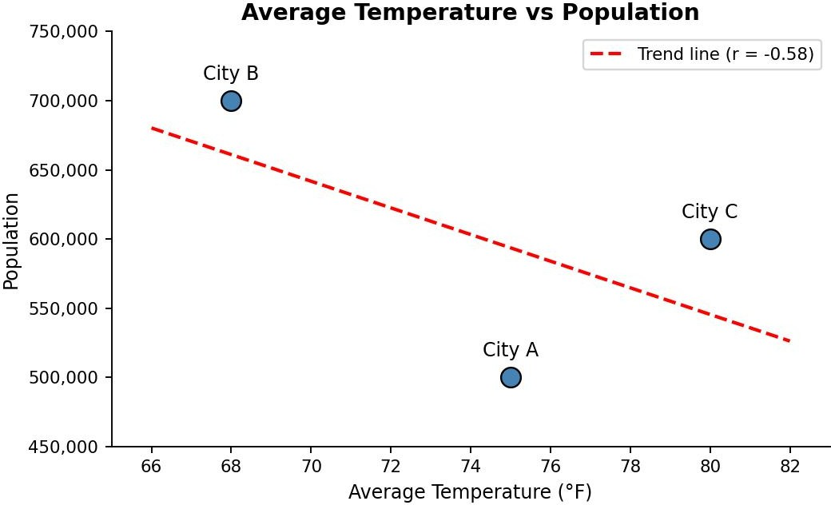

Output 2: Average Temperature vs Population (Scatter Plot)
Observation: The correlation between average temperature and population is about -0.58, so the trend line slopes downwards: the cooler city (City B, 68°F) has the largest population, while the warmer cities have fewer people. The line suggests roughly 9,600 fewer people for every 1°F rise in temperature.
Insight: The relationship is only moderate, and it is not a clean line. City A has a middle temperature (75°F) but the smallest population, below warmer City C. With only three cities, this shows a possible pattern and not proof that temperature affects population.

PROGRAM 3: Table of Geographic Data for Each City
Build a table to display the geographic data for each city. Label the table elements.
geo <- data.frame(
City = c("City A", "City B", "City C"), Population = c(500000, 700000, 600000),
Avg_Temperature = c(75, 68, 80),
Elevation = c(1000, 800, 1200)
)

print(geo)

sum(geo$Population) mean(geo$Avg_Temperature)

mean(geo$Elevation)

OUTPUT:
Console Output

City |  | Population | Avg_Temperature | Elevation
1 City A |  | 500000 | 75 | 1000
2 City B |  | 700000 | 68 | 800
3 City C |  | 600000 | 80 | 1200
[1] | 1800000
[1] | 74.33333
[1] | 1000

Output 3a: Geographic Data Table (R Console)

City | Population | Avg. Temperature (°F) | Elevation (ft)
City A | 500000 | 75 | 1000
City B | 700000 | 68 | 800
City C | 600000 | 80 | 1200
Total / Average | 1800000 | 74.33 | 1000
Output 3b: Geographic Data Table with Total and Averages
Observation: The table gives the exact population, average temperature and elevation of each city. The three cities have a combined population of 1,800,000, an average temperature of about 74.3°F and an average elevation of 1,000 ft. City B is the largest, coolest and lowest-lying city, while City C is the warmest and highest.

PROGRAM 4: Interactive Geographic Dashboard in Tableau
Develop a Tableau dashboard combining the map chart, scatter plot and the table for interactive exploration of geographic data.

Steps in Tableau
- Save the data as an Excel or CSV file with Latitude and Longitude columns added for each city, and connect to it in Tableau (Connect > Microsoft Excel / Text file). Right-click Latitude and Longitude and set Geographic Role to Latitude and Longitude.
- Sheet 1 (Map Chart): Double-click Latitude and Longitude to create the map. Drag City to Label, Population to Size and Avg. Temperature to Color. Rename the sheet "City Map".
- Sheet 2 (Scatter Plot): Drag Avg. Temperature to Columns and Population to Rows (both SUM). Drag City to Label and Detail, then use Analytics > Trend Line to add a trend line. Rename the sheet "Temperature vs Population".
- Sheet 3 (Table): Drag City to Rows, Measure Names to Columns and Measure Values to Text. Keep Population, Avg. Temperature and Elevation in Measure Values. Rename the sheet "City Table".
- Create a new Dashboard (Dashboard > New Dashboard), set the size to Automatic, and drag the three sheets onto the dashboard area.

- Add interactivity: select each chart and click Use as Filter, so clicking a city in one view filters the others. Add a City filter (Show Filter > Apply to Worksheets > All Using This Data Source).
- Add the title "Geographic Data Dashboard" and test the filters in Presentation Mode.

OUTPUT:
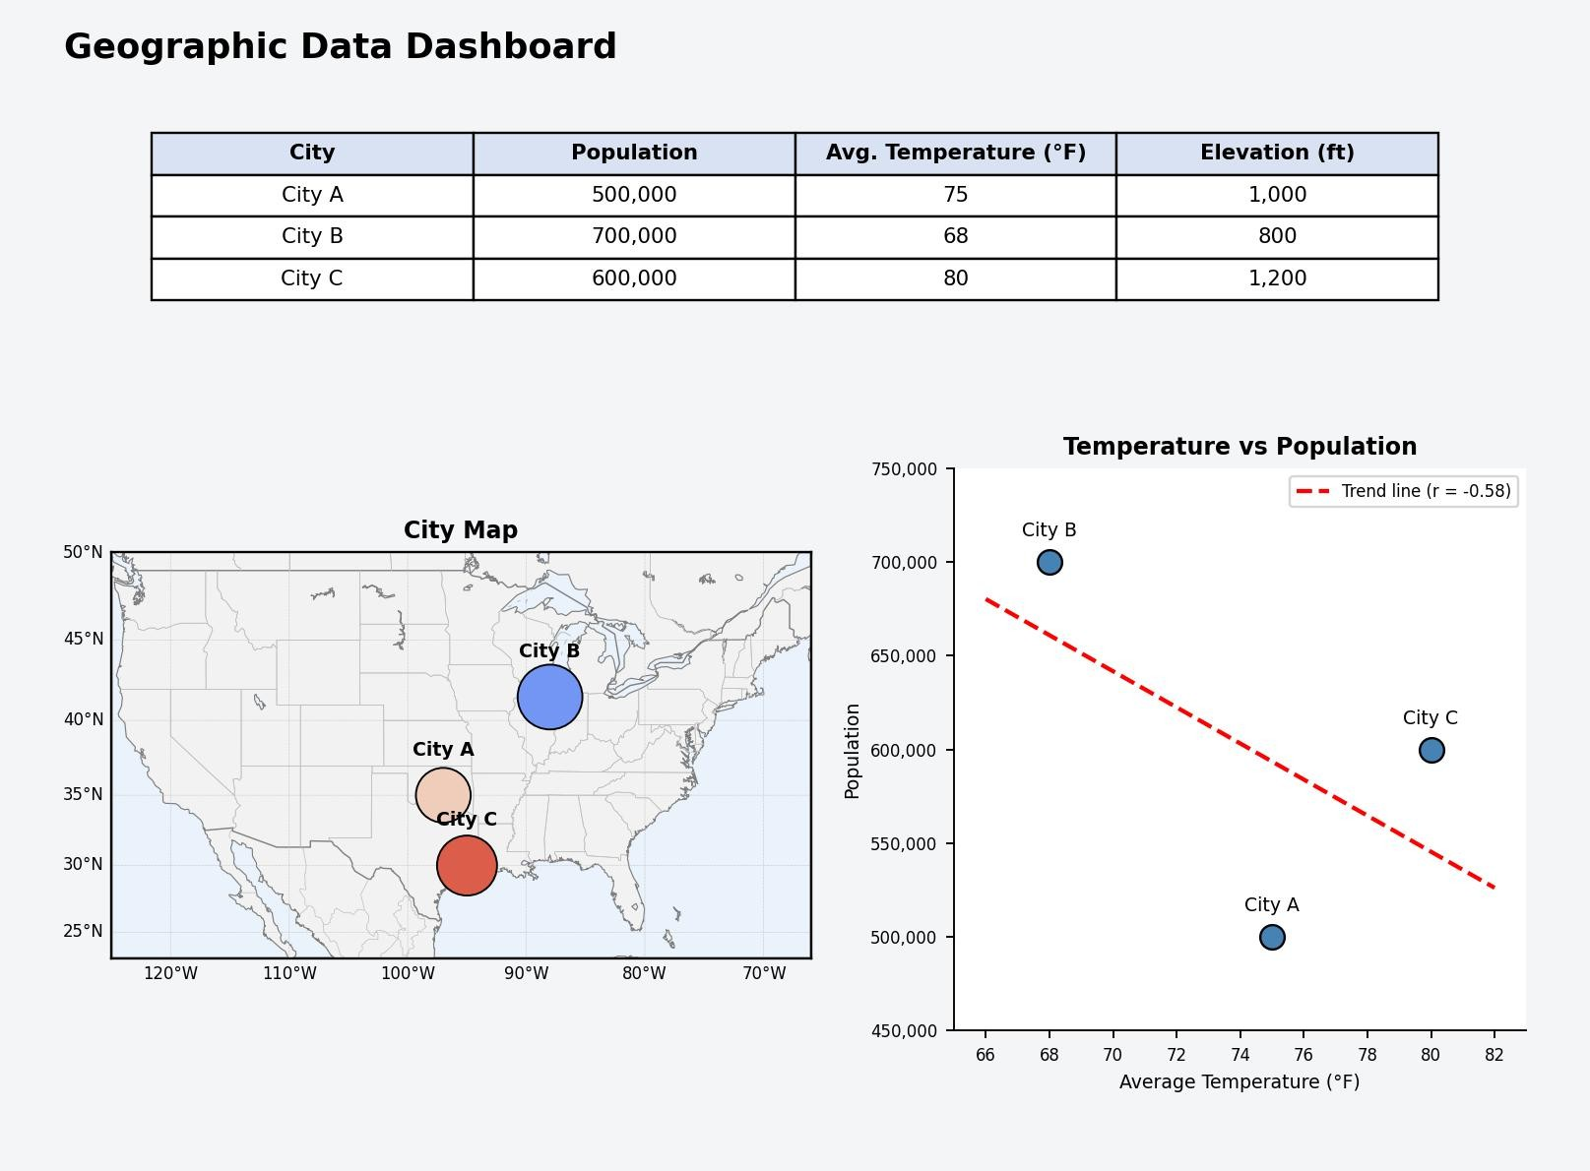
Output 4: Interactive Geographic Dashboard (Tableau)
Observation: The dashboard shows the city map, the temperature and population relationship and the data table together. Selecting a city in any view filters the other two.

Procedure
- Define the geographic data of the cities in R as a data frame with City, Population, Avg_Temperature, Elevation and the assigned coordinates.
- Use ggplot2 with map_data() and geom_point() to draw the map chart of the cities.
- Use plot() with lm() and abline() to draw the scatter plot of temperature against population, and cor() to measure the relationship.
- Display the data with print() and calculate the total population and the average temperature and elevation with sum() and mean().
- Load the geographic file into Tableau and build the map, scatter plot and table worksheets.
- Combine the worksheets in a Tableau dashboard and add filters and actions for interactivity.

RESULT:
The geographic data of the cities was successfully analyzed using a map chart, a scatter plot and a data table in R. An interactive Tableau dashboard was also created, combining all three views so that users can explore the cities by location, temperature and population.

Key Functions and Tools Used

Function / Tool | Purpose
data.frame() | Creates the geographic data table.
map_data() / geom_polygon() | Loads and draws the base map outline.
geom_point() / geom_text() | Plots and labels the cities on the map.
plot() / lm() / abline() | Creates the scatter plot with a trend line.
cor() | Measures the relationship between temperature and population.
print() / sum() / mean() | Displays the table and calculates total and average values.
Tableau Map / Dashboard | Builds the map view and combines worksheets with filters and actions.

